# 3rd Lecture.

Laplace, Fourier Transforms

1. Example

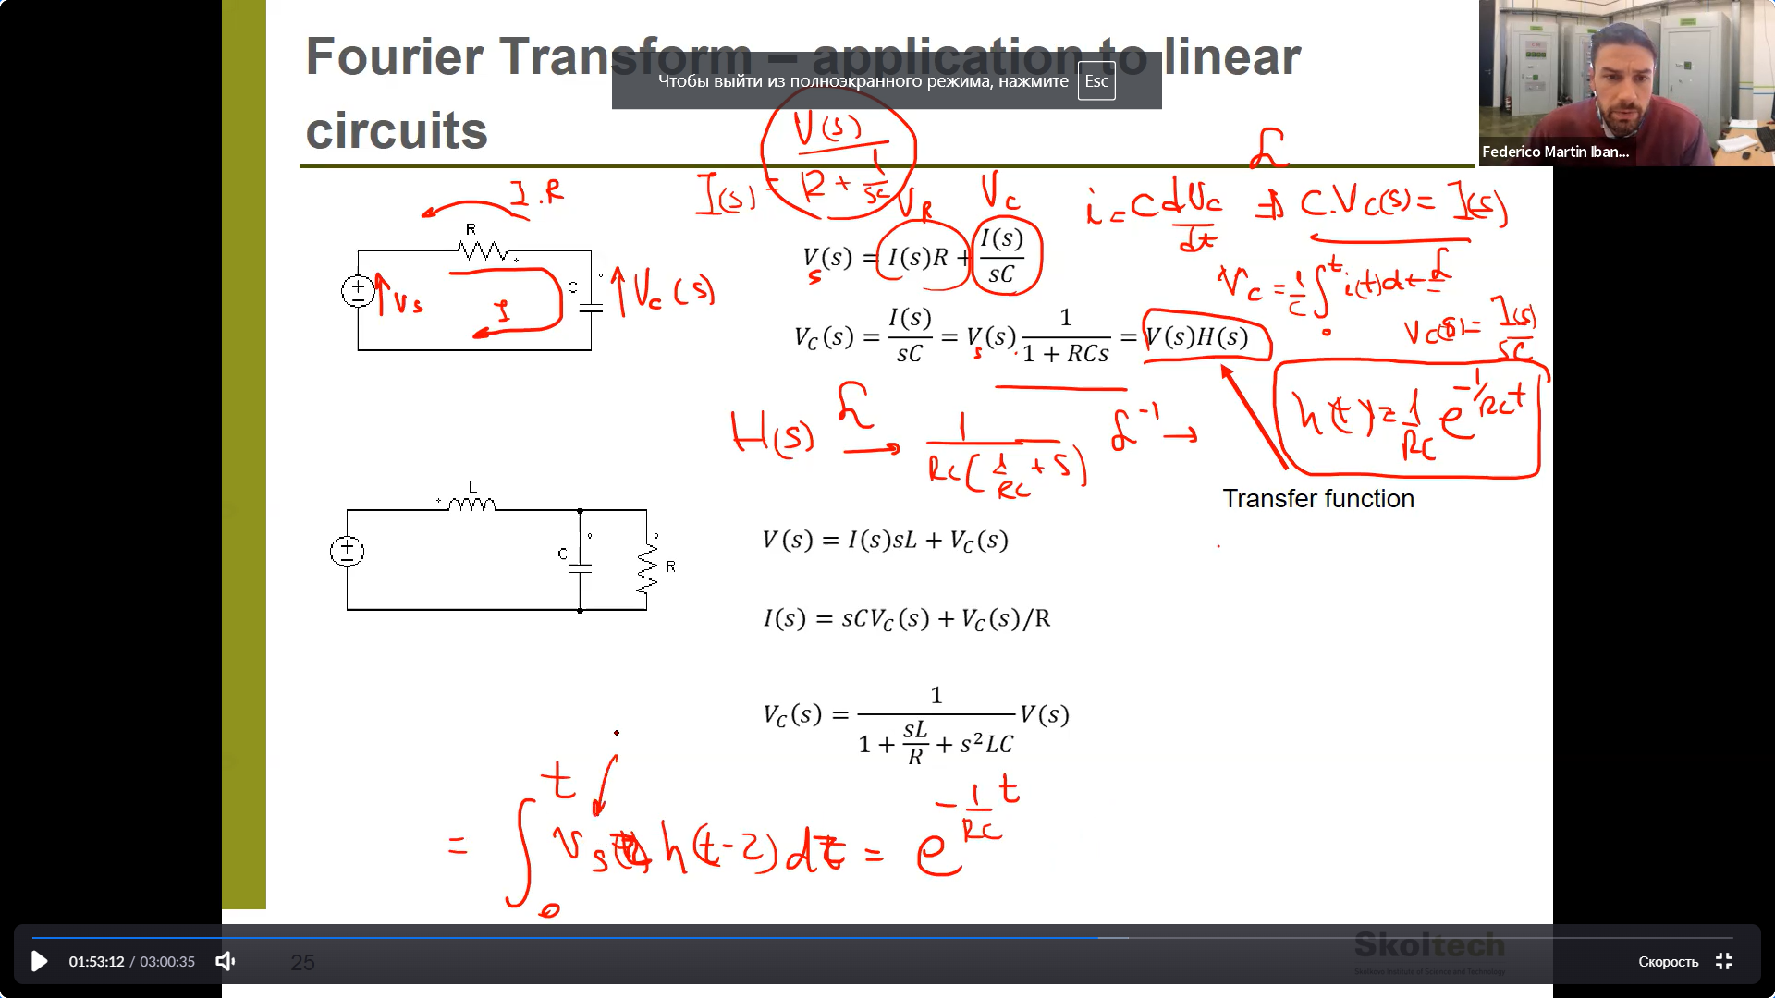

$V_{s}\left(s\right),V_{c}\left(s\right),I\left(s\right)-$ Laplace transformes.

$$i_{c}=i=C\frac{dv_{c}}{dt}=>L\left(i\right)=L\left(C\frac{dv_{c}}{dt}\right)=sCV_{c}\left(s\right)=I\left(s\right)$$

$$V_{s}=V_{R}+V_{c}=I\left(s\right)R+\frac{I\left(s\right)}{sC}$$

We’re going to find $V_{c}$.

$$V_{c}=\frac{I\left(s\right)}{sC}=\frac{sCV_{s}}{RsC+1}\frac{1}{sC}=\frac{V_{s}}{RsC+1 }=V_{s}(s)H(s)$$

Where $H\left(s\right)=\frac{1}{RsC+1 }=\frac{1}{RC}\left(\frac{1}{s+\frac{1}{RC}}\right)=>h\left(t\right)=\frac{1}{Rc}\exp\left(-\frac{1}{Rc}t\right)$

$$v_{c}=L^{-1}\left(V_{c}\right)=L^{-1}\left(V_{s}(s)H(s)\right)=L^{-1}\left(L(v_{s}(t)*h(t))\right)=v_{s}\left(t\right)*h\left(t\right)=\int_{0}^{t}{v_{s}\left(τ\right)h\left(t-τ\right)dτ}=\int_{0}^{t}{v_{s}\left(τ\right)h\left(t-τ\right)dτ}=V\int_{0}^{t}{h\left(t-τ\right)dτ}=V\int_{0}^{t}{\frac{1}{Rc}e^{\left(\frac{1}{Rc}τ-\frac{1}{Rc}t\right)}dτ}=\frac{V}{Rc}e^{\left(-\frac{1}{Rc}t\right)}\int_{0}^{t}{e^{\left(\frac{1}{Rc}τ\right)}dτ}=\frac{V}{Rc}e^{\left(-\frac{1}{Rc}t\right)}RCe^{\left(\frac{1}{Rc}τ\right)}{\left.​\right|}_{0}^{t}=Ve^{\left(-\frac{1}{Rc}t\right)}\left(e^{\left(\frac{1}{Rc}t\right)}-1\right)= V\left(1-e^{\left(-\frac{1}{Rc}t\right)}\right)$$

$$v_{c}= V\left(1-e^{\left(-\frac{1}{Rc}t\right)}\right)$$

Sometimes it is better to solve diff eq.

Or you can solve this: ($V_{s}\left(s\right)=L\left(v_{s}\right)=\frac{V}{s})$

$$V_{c}=\frac{V_{s}}{RsC+1 }=\frac{V}{s} \frac{1}{RsC+1 }$$

$$v_{c}=L^{-1}\left(V_{c}\right)=L^{-1}\left(\frac{V}{s} \frac{1}{RsC+1 }\right)$$

1. Example

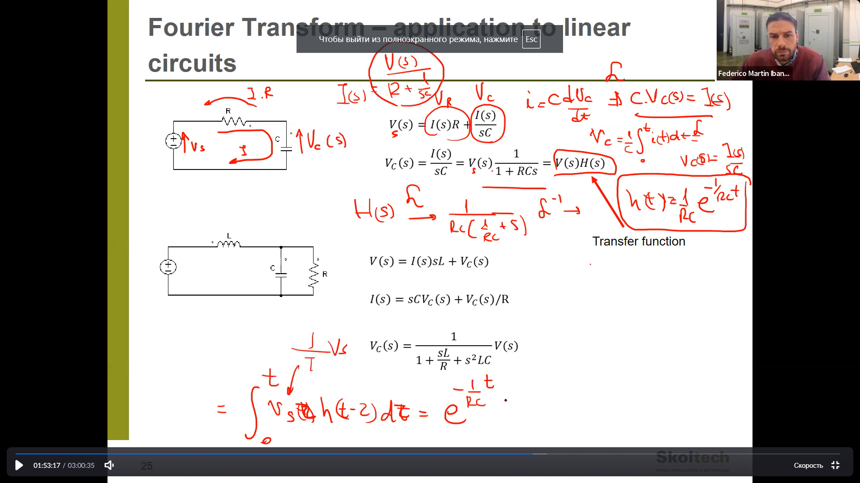

$$V_{s}=I\left(s\right)sL+V_{c}$$

$$I\left(s\right)=CsV_{c}\left(s\right)+\frac{V_{c}\left(s\right)}{R}$$

$$V_{s}=I\left(s\right)sL+V_{c}$$

$$V_{s}=\frac{V_{c}\left(s\right)\left(CsR+1 \right)}{R}sL+V_{c}=V_{c}\left(Cs^{2}L+\frac{sL}{R}+1\right)$$

$$V_{c}=\frac{V_{s}}{\left(Cs^{2}L+\frac{sL}{R}+1\right)}$$

1. Fourier transform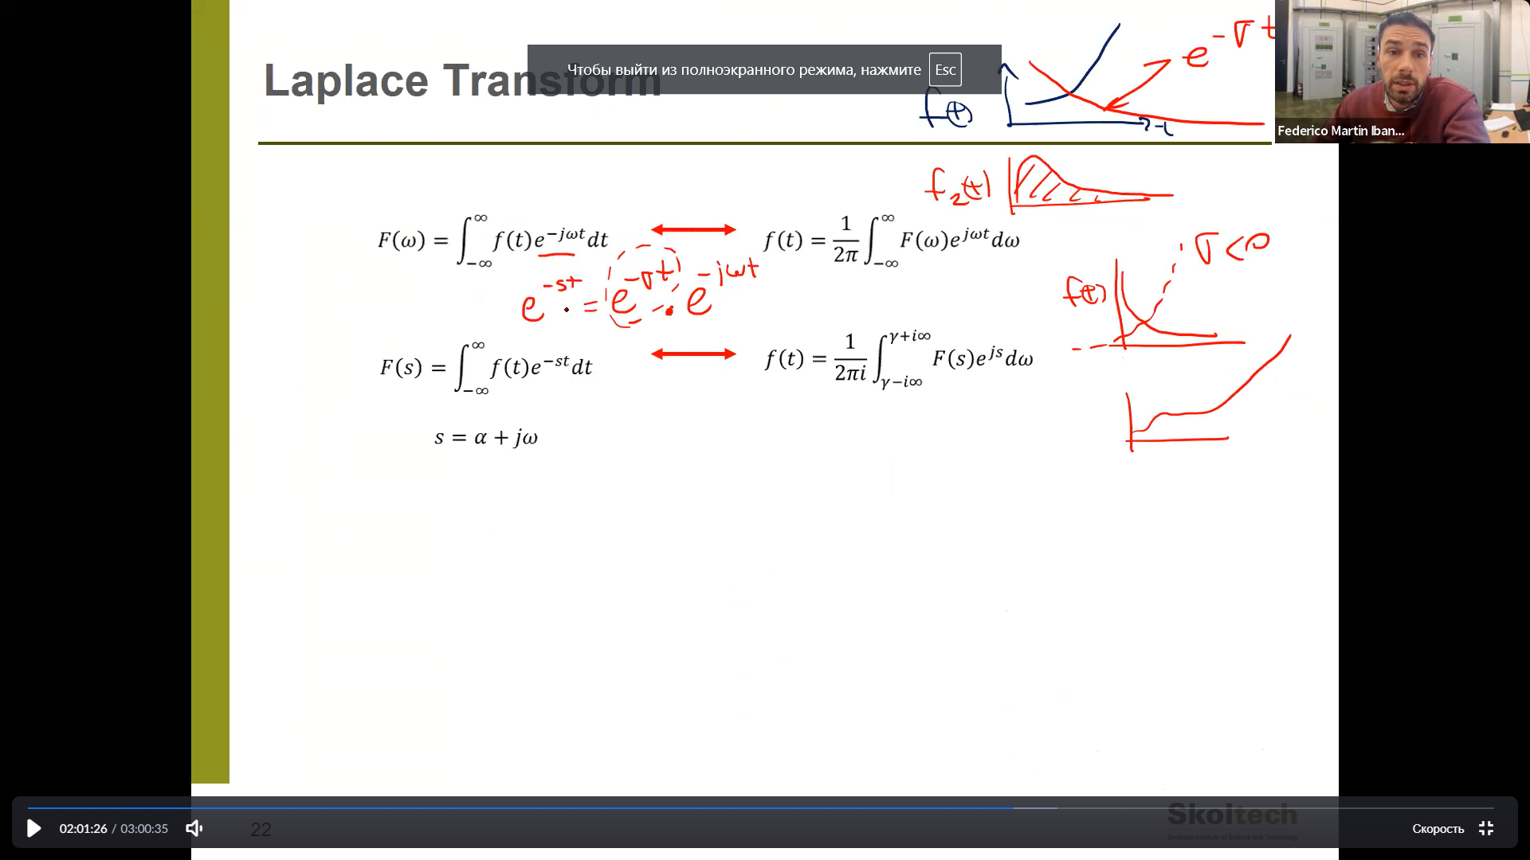

We can change in Laplace s on jw and it is Fourier transform.

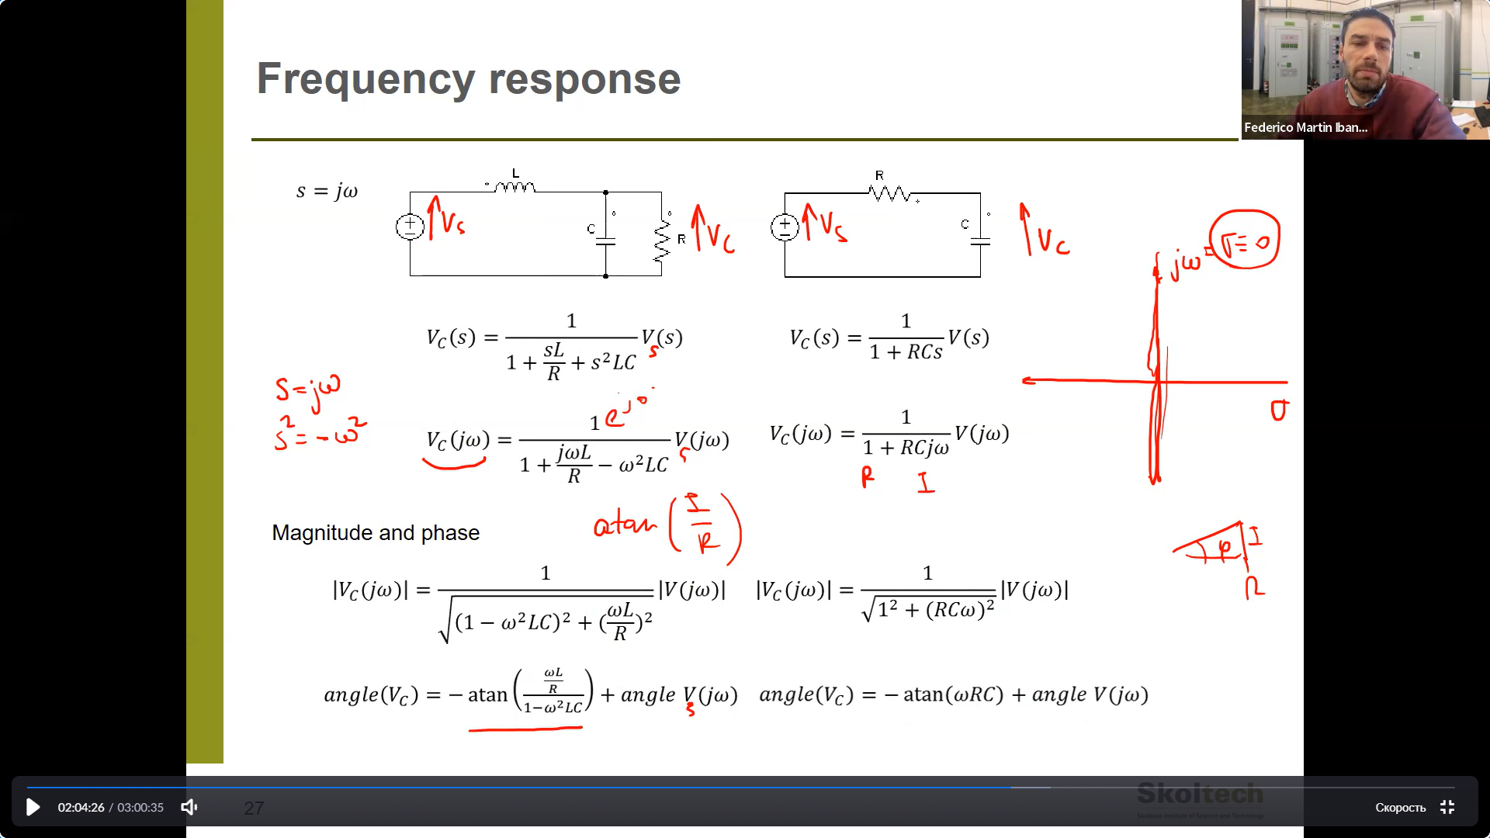angle is imag_part/real_part.

1. Analysis of domains:
2. When $w->0$
3. When $w->∞$
4. When real part cancels.

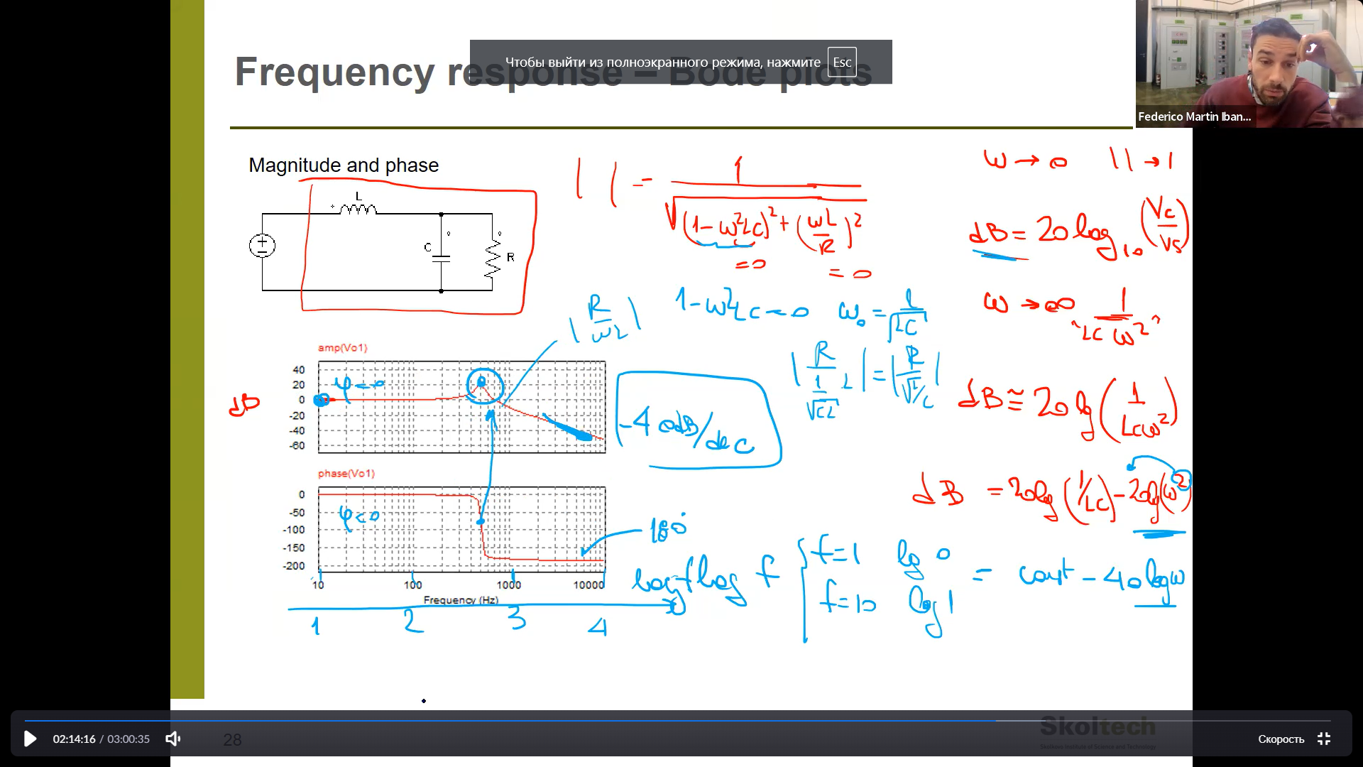

1. Analysis of circuit.

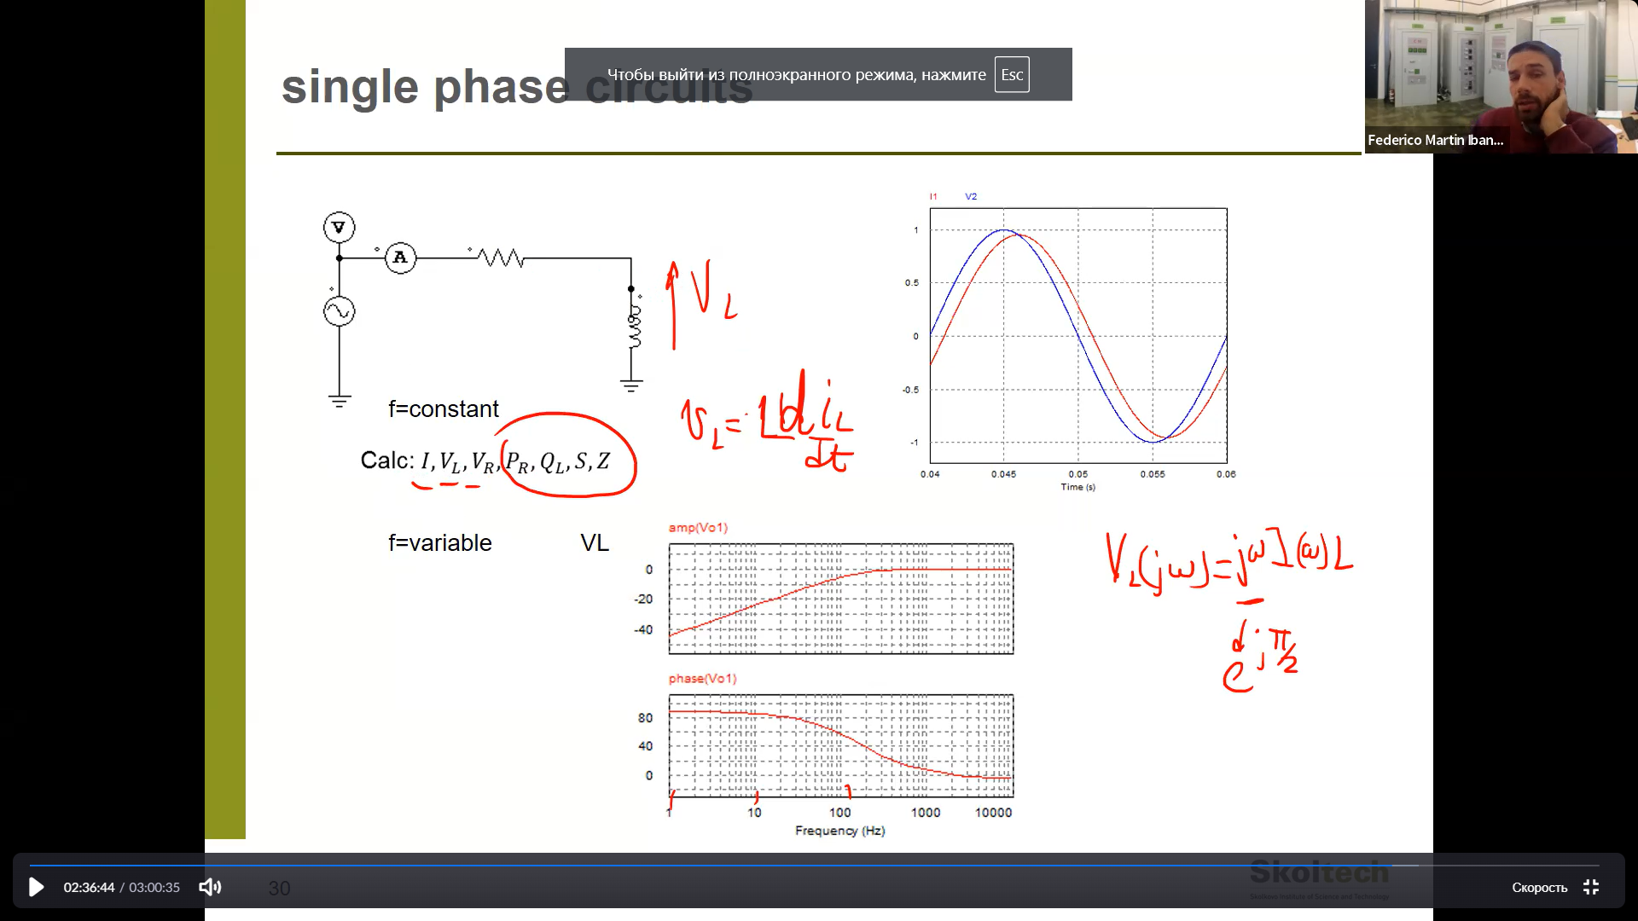

1. Let’s talk about the power

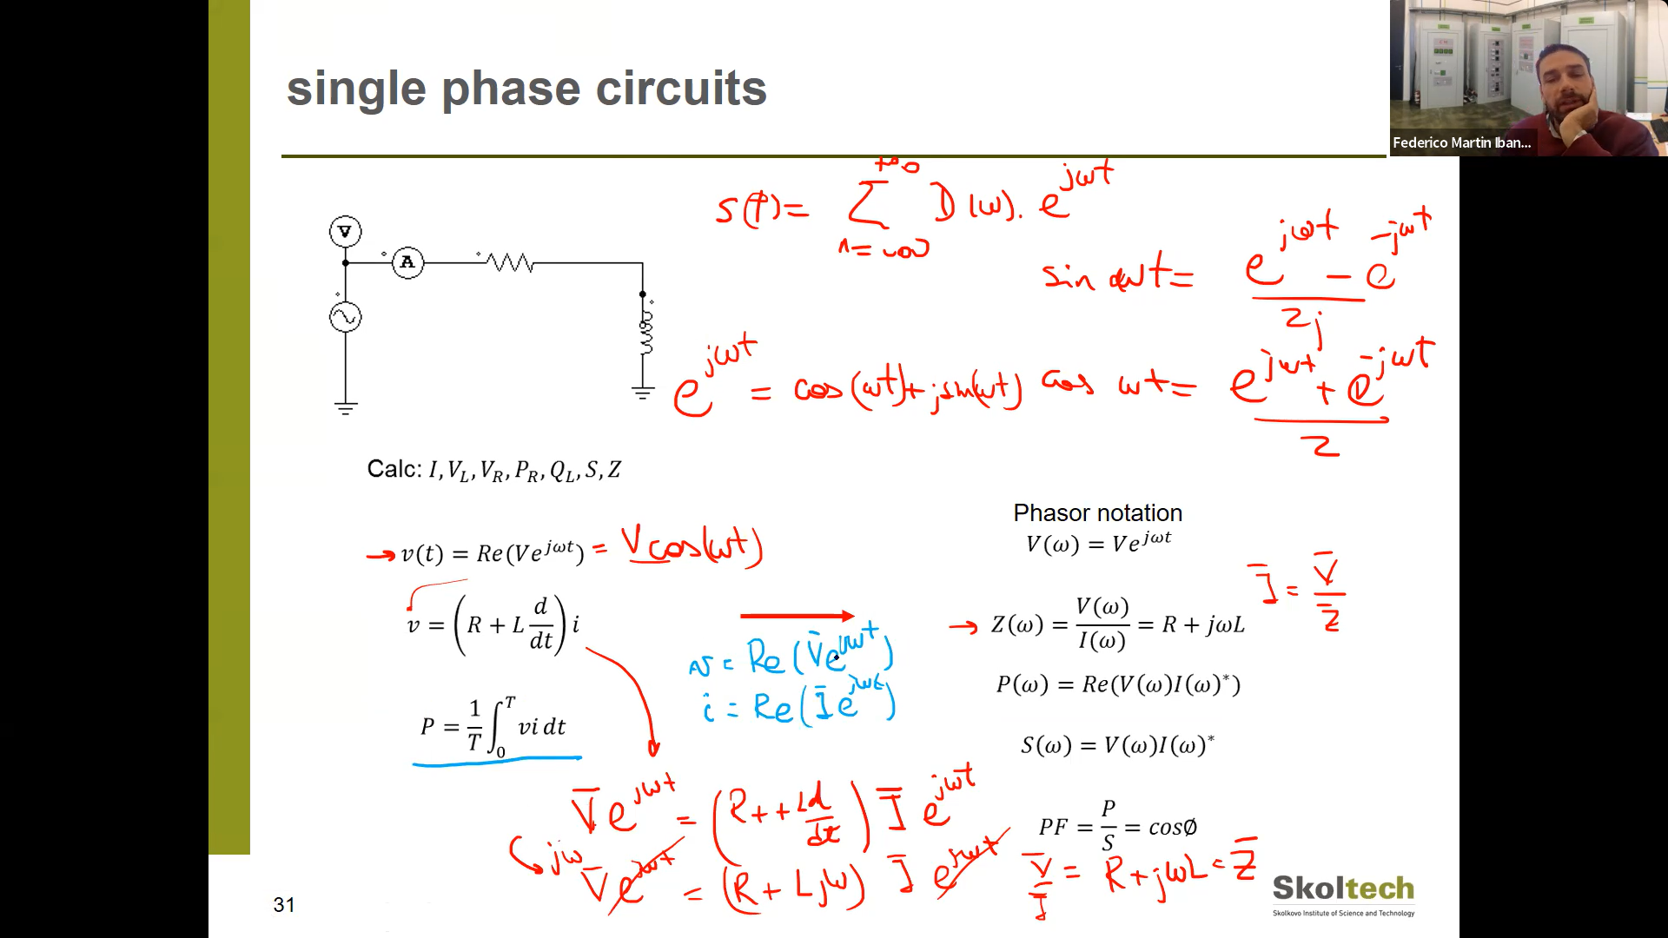

Consider voltage as some im * exp and the same for current( because we assume voltage is single cos signal with a shift in V, we assume that current is the same frequency with maybe shift in I)

Find Power P

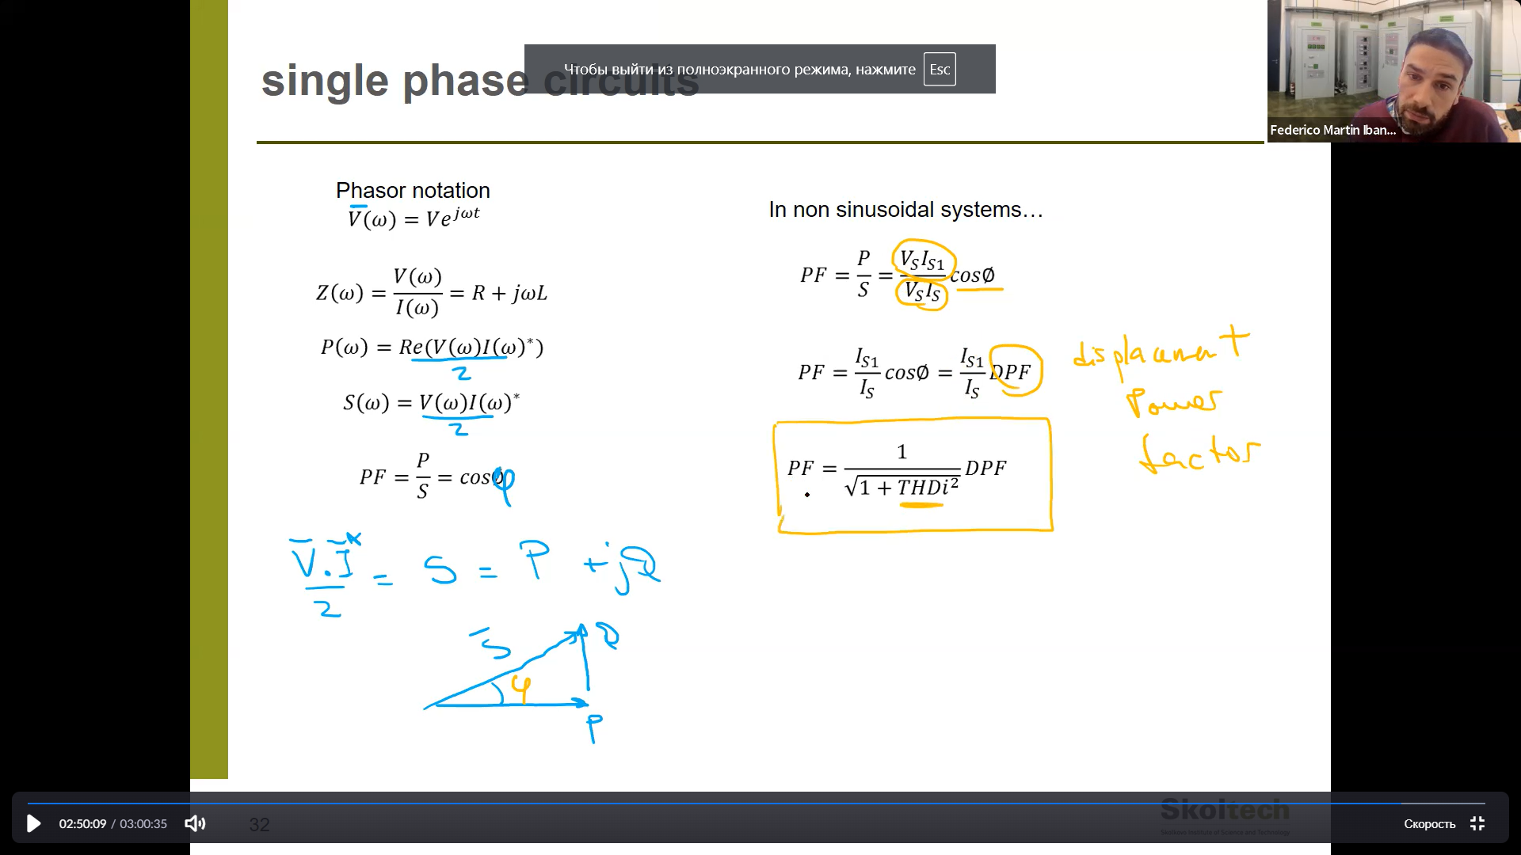

There are S (apparent power) consists of P (power), Q (reactive power)

PF – is the power factor.

For nonsinusoidal signal systems:

We extract the first harmonic and divide it by full power to define PF – power factor.

1. 3 phase circuits:

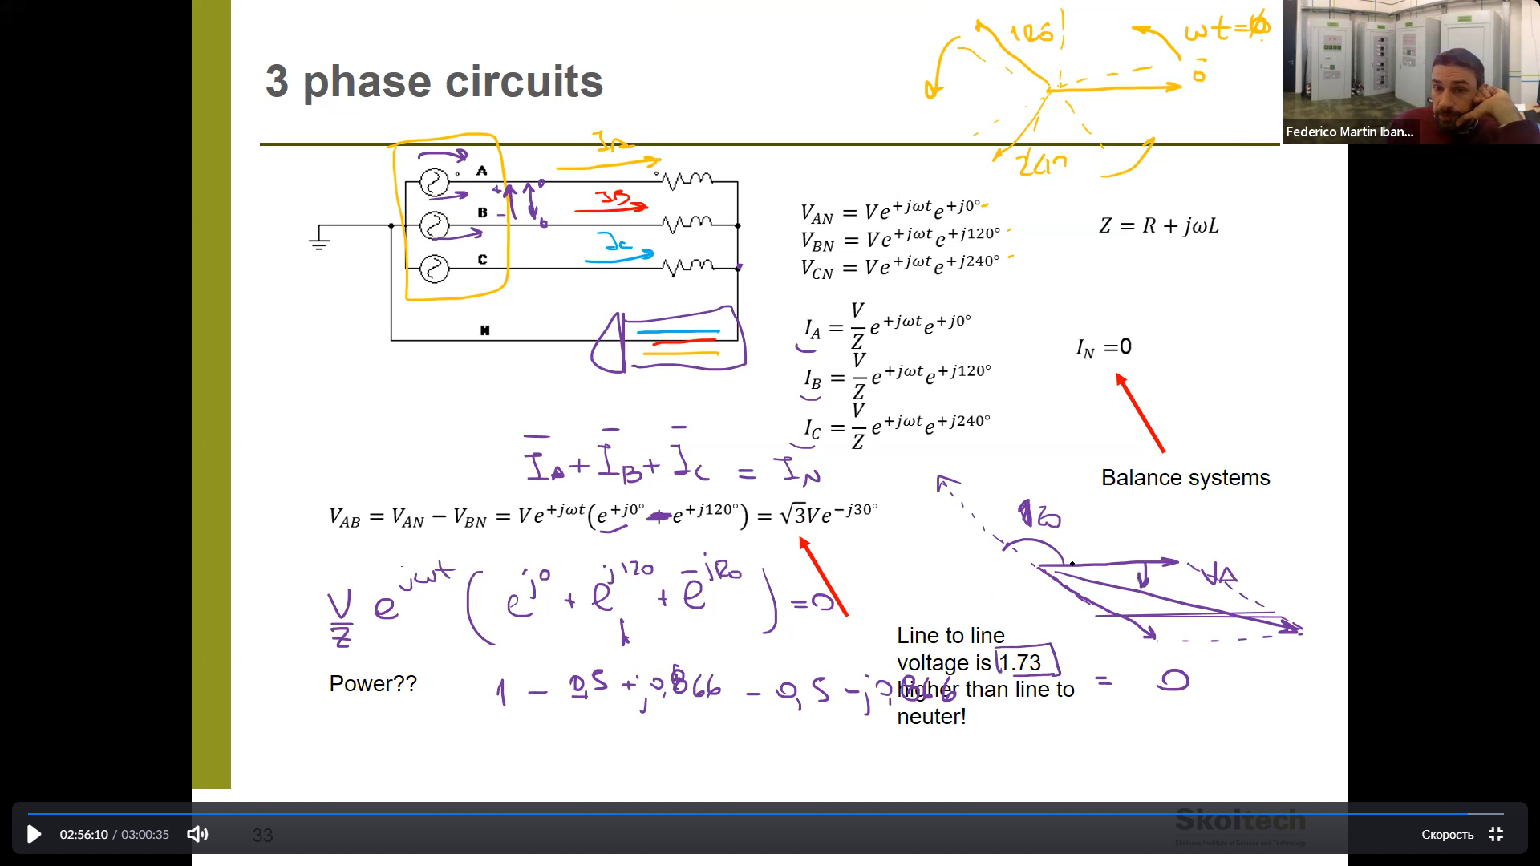

If we sum all currents from A, B,C sources we get 0. – it means that there is no current in N.

Also accidentally want to calculate voltage between AB it turns to larger voltage, with the shift.